
STUDENT CASE STUDY EXECUTION REPORT
Department | CSE
Subject | DSA-2
Academic Year | I-III Semester (2025-26)
Faculty Name | Dr.N.Chaitanya Kumar
Student Name | SRIRAM
Roll number | 2520030218
Branch | CSE
Course Outcome | CO-3

Case Study Topic: AirLink Airport Route Network Analysis using BFS Graph Traversal
Work Done Summary:
In this project, we developed an Airport Route Network Analysis System using Graphs and Breadth First Search (BFS). Airports were represented as vertices and flight routes as edges in the graph. BFS traversal was used to explore connected airports and identify reachable destinations from a selected airport. This project demonstrated how graphs can be used to model airport networks and how BFS helps in efficient route and connectivity analysis.
Implementation Details:
- Created graph representation using adjacency lists.
- Modeled airports as graph vertices.
- Modeled flight routes as graph edges.
- Implemented BFS traversal algorithm.
- Maintained visited airport records.
- Used queue data structure for traversal.
- Analyzed airport connectivity.
- Generated route connectivity report.
Result:Screenshots/ Output
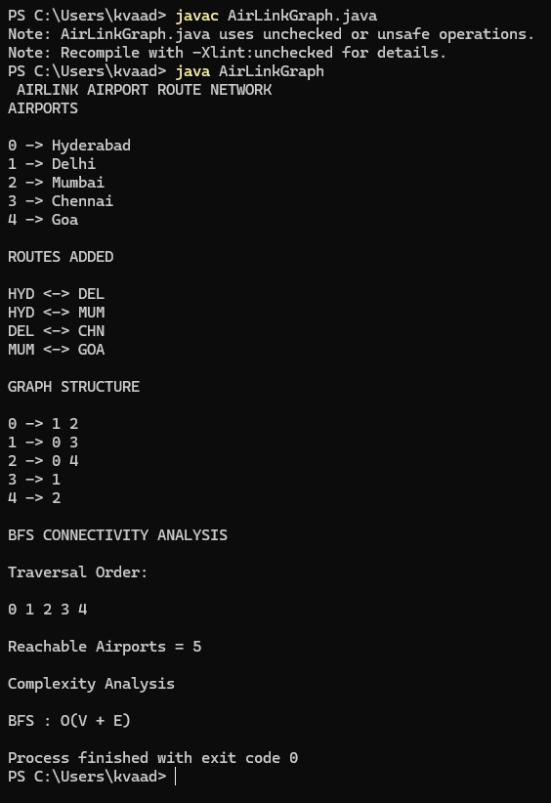
The graph-based airport network successfully identified all reachable airports from the source airport using BFS traversal.
Time Complexity:
- BFS Traversal : O(V + E)
- Space Complexity : O(V)
Where:
- V = Number of Airports
- E = Number of Flight Routes
The graph representation efficiently handled route connectivity analysis for airport operations.

GitHub Link: https://github.com/sriram912/DSA.git
Student Signature | Faculty Signature
________________________ | __________________________

